Project Design Phase
Proposed Solution Template

Date | 03 April 2026
Team ID | SWTID-2026-8629
Project Name | Smart Library
Maximum Marks | 2 Marks

Solution Architecture:
Solution architecture is the process of designing a structured framework that connects business problems with appropriate technology solutions. It defines how different components of the system interact with each other and ensures that the system meets business requirements effectively.
The main goal of this solution architecture is to develop an efficient and scalable system for managing employee data in an automated way.

Example - Solution Architecture Diagram:

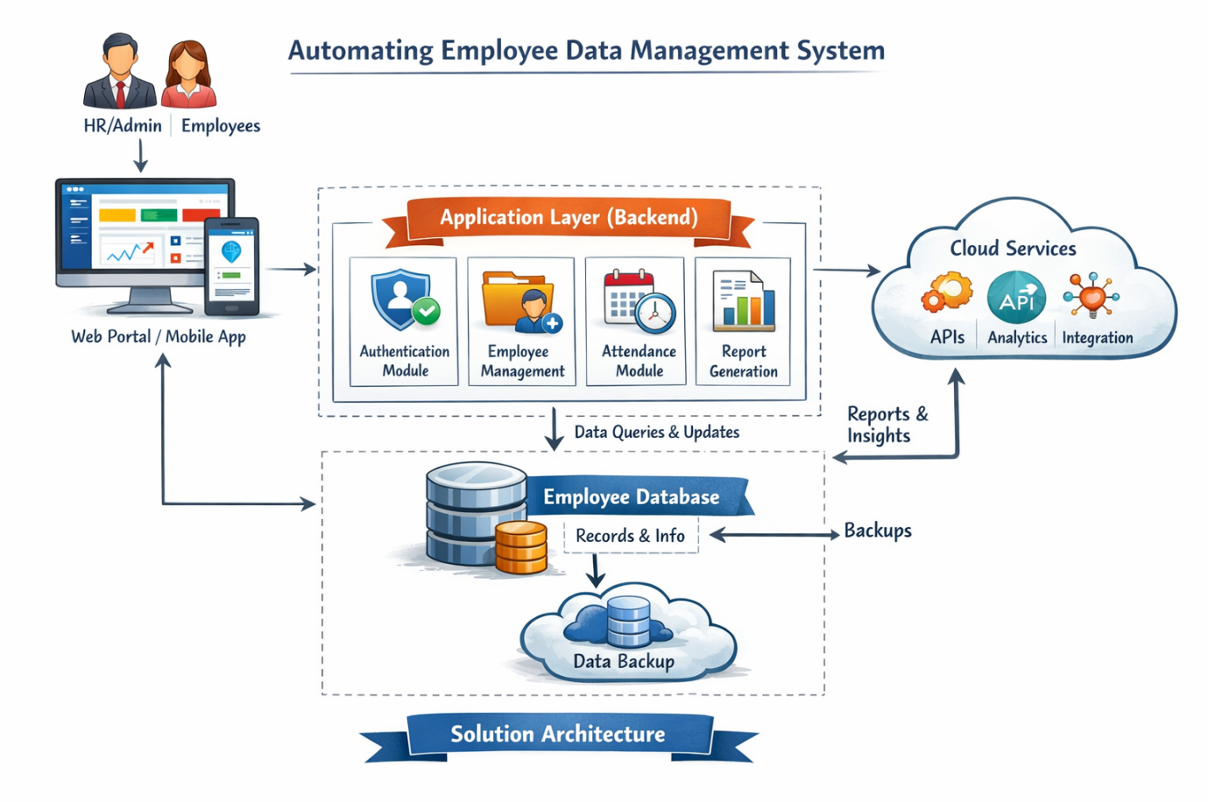

1. Overview of the Architecture
The proposed system follows a three-tier architecture:
- Presentation Layer (Frontend):
This is the user interface where HR and employees interact with the system. It can be developed using web technologies like HTML, CSS, and JavaScript.
- Application Layer (Backend):
This layer processes user requests, applies business logic, and controls the system functionalities such as data validation, authentication, and report generation.
- Data Layer (Database):
This layer stores all employee-related data such as personal details, attendance, and records securely in a database (e.g., MySQL).

2. System Components
- User Interface: Allows users to log in, view, and update employee data.
- Authentication Module: Ensures secure login using username and password.
- Employee Management Module: Handles adding, updating, and deleting employee records.
- Attendance Module: Tracks employee attendance automatically.
- Report Generation Module: Generates reports for management analysis.
- Database: Stores all system data securely.

3. Data Flow
- The user logs into the system through the frontend.
- The request is sent to the backend server.
- The backend validates the request and processes it.
- Data is retrieved or updated in the database.
- The response is sent back to the user interface and displayed.

4. Key Features of the Architecture
- Secure and role-based access control
- Real-time data processing
- Scalable and modular design
- Easy integration with future technologies
- Reliable data storage and backup

5. Development Phases
- Requirement Analysis
- System Design
- Development
- Testing
- Deployment
- Maintenance

6. Conclusion
This solution architecture ensures that the employee data management system is efficient, secure, and scalable. It bridges the gap between business needs and technical implementation by clearly defining system structure and workflow.

Solution Architecture – Smart Library System

Solution Architecture
Solution architecture is the process of designing a structured framework that connects user needs with appropriate technology solutions. It defines how different components of the Smart Library System interact and ensures that the system meets functional and performance requirements effectively.
The main goal of this architecture is to develop an efficient and scalable system for managing library operations in an automated way.

1. Overview of the Architecture
The proposed system follows a three-tier architecture:
• Presentation Layer (Frontend):
This is the user interface where students and librarians interact with the system. It can be developed using web technologies like HTML, CSS, JavaScript, and React.
• Application Layer (Backend):
This layer processes user requests, applies business logic, and controls functionalities such as book management, authentication, issue/return process, and report generation.
• Data Layer (Database):
This layer stores all library-related data such as books, users, transactions, and reports securely in a database (e.g., MySQL / MongoDB).

2. System Components
- User Interface: Allows users to log in, search books, and perform operations
- Authentication Module: Ensures secure login using email/password or social login
- Book Management Module: Handles adding, updating, deleting, and searching books
- Issue/Return Module: Manages book issue, return, due dates, and fine calculation
- Notification Module: Sends alerts for due dates, approvals, and updates
- Report Generation Module: Generates reports (issued books, overdue, availability)
- Database: Stores all system data securely

3. Data Flow
- The user logs into the system through the frontend
- The request is sent to the backend server
- The backend validates the request and processes it
- Data is retrieved or updated in the database
- The response is sent back to the user interface and displayed

4. Key Features of the Architecture
- Secure and role-based access control (Admin / User)
- Real-time book availability tracking
- Scalable and modular design
- Easy integration with future technologies
- Reliable data storage and backup

5. Development Phases
- Requirement Analysis
- System Design
- Development
- Testing
- Deployment
- Maintenance

6. Conclusion
This solution architecture ensures that the Smart Library System is efficient, secure, and scalable. It clearly defines system structure and workflow, helping to deliver a user-friendly and reliable library management solution.

